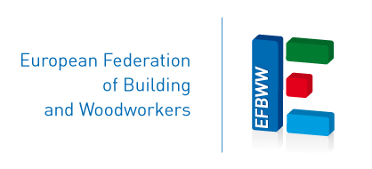

PRESS RELEASE

On 24 September, the European Federation of Building and Woodworkers (EFBWW) and the European Construction Industry Federation (FIEC) will hold an online conference on Undeclared Work in the Construction Industry.

The Conference is part of the European week of action to raise awareness and promote the benefits of declared work: #EU4FairWork.

According to the latest Eurobarometer survey (2019), 21% of all undeclared jobs were to be found in the construction sector
Undeclared work in the construction industry remains a major challenge for the whole sector, as it affects good and safe working conditions for workers, fair competition between construction companies and the long-term financial sustainability of national social security and tax systems.

The Conference will be the starting point for a long-term commitment to tackle Undeclared Work in the construction industry.
You are invited to register for the conference via this link.
The meeting agenda is attached.

Besides senior EFBWW and FIEC representatives, the event will be joined by Lucia Nicholsonová, Chair of the EMPL Committee of the European Parliament and Jordi Curell, Director of Labour Mobility at the European Commission (DG EMPL) and Interim Executive Director of the European Labour Authority (ELA).

Contact
EFBWW - Paula Cravina de Sousa
+32473134349
pcravina@efbww.eu

FIEC - Yasmina Koeune
y.koeune@fiec.eu

